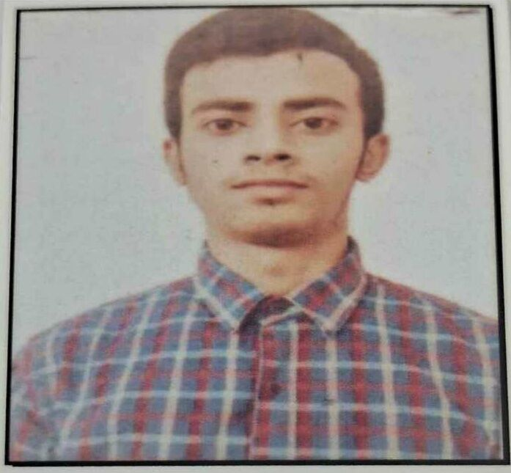
ARYAN ADARSH
RESUME
Quant Developer

Address- jinedpur
from Begusarai, Bihar
Pin- 851131

Mobile No- 8989767654
E-mail- aryan123
To Leverage my strong foundation in mathematical programming, and financial modeling to build efficient quantitative trading strategies and tools, while continuously learning advance techniques in algorithmic trading and risk management.
CAREER OBJECTIVE
ACADEMIC QUALIFICATION
Course | Discipline | School/College | Board/University | Passing Year | % / CGPA
B-Tech | CSE | College |  | 2029*
XII | Science | School | CBSE | 2025 | 80%
X | General | School | CBSE | 2022 | 93%

* Currently pursuing B-tech in 1st semester
1. NTSE Scholar
SCHOLARSHIP
2. KVPY fellowship

Programming languages: C
TECHNICAL SKILL
PERSONAL PROFILE
Name: Aryan Adarsh
Father’s Name: Amar Nath Sinha
Mother’s Name: Archana Kumari
Date of Birth: 01/09/2007
Sex: Male
Martial Status: Unmarried
Nationality: Indian

I hereby declare that the above mentioned information is correct to the best of my knowledge and I bear the responsibility for the correctness of the above mentioned particulars.
DECLARATION

Date: 17 september 2025 Aryan Adarsh

